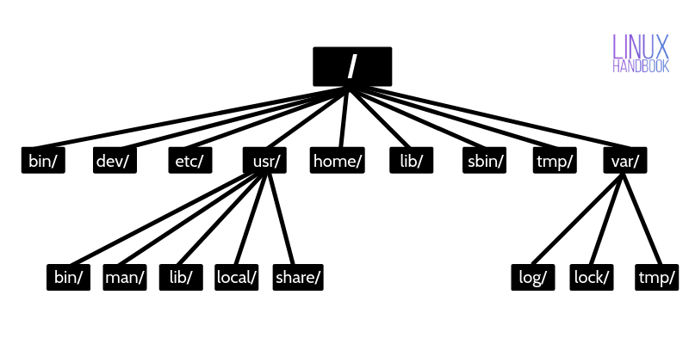

**User Account Management**

**Creating and Managing Groups:**

1. useradd:

- The `useradd` command is used to add a new user to the system. However, it primarily creates the user account without setting a password or home directory.

- Options:

- `-m`: Create the user's home directory.

- `-g group`: Set the initial login group.

- `-s shell`: Specify the user's login shell.

2. adduser:

- The `adduser` command is a high-level interface to `useradd`. It is more user-friendly and interactively prompts for information such as the password and user details.

- It automatically creates a home directory and sets up the user environment.

3. usermod:

- `usermod` modifies user account properties. Common options include:

- `-aG groups`: Add the user to additional groups.

- `-s shell`: Change the user's login shell.

- `-L`: Lock the user account.

- `-U`: Unlock the user account.

4. userdel:

- The `userdel` command deletes a user account. However, it does not remove the user's home directory.

- Options:

- `-r`: Remove the user's home directory and mail spool.

5. deluser:

- The `deluser` command is a user-friendly alternative to `userdel` and removes the user's home directory by default.

- Options:

- `--remove-home`: Remove the home directory.

**Creating and Managing Groups:**

6. groupadd:

- `groupadd` creates a new group with the specified name.

- Options:

- `-g gid`: Set the group ID.

7. addgroup:

- `addgroup` is similar to `groupadd` but might prompt for additional information, such as adding users to the group during creation.

8. groupdel:

- The `groupdel` command deletes a group. If the group is the primary group of any users, it must be changed using `usermod` before deletion.

9. delgroup:

- Similar to `groupdel`, `delgroup` may remove group members in addition to deleting the group.

**Switching Users and sudo Access:**

10. su (Switch User):

- `su` allows you to switch to another user, usually the superuser (root). The `-` option simulates a full login, updating the environment to that of the target user.

11. sudo (Superuser Do):

- `sudo` allows a permitted user to execute a command as the superuser or another user, as specified in the `/etc/sudoers` file.

- Users in the "sudo" group have sudo privileges.

- Configured in `/etc/sudoers` using the `visudo` command.

- Examples:

- `sudo command`: Execute a command with superuser privileges.

- `sudo -u username command`: Execute a command as another user.

Understanding and using these commands effectively is crucial for system administrators and users managing their Linux systems. Always consult the man pages (`man command`) for detailed information on each command's options and usage.

**Monitor User Activity:-**

In Linux, there are several commands you can use to monitor user activity and information. Here are some common commands: `who`, `last`, `w`, and `id`.

1. `who` Command:

The `who` command displays information about users who are currently logged in.

```bash

who

```

- Example output:

```bash

user1 pts/0 2022-01-01 10:00 (:0)

user2 pts/1 2022-01-01 11:30 (:1)

```

This output provides information about currently logged-in users, their terminal (pts/0), login time, and originating IP or display.

2. `last` Command:

The `last` command shows a list of last logged-in users and their login history.

```bash

last

```

- Example output:

```bash

user1 pts/0 Fri Jan 1 10:00 still logged in

user2 pts/1 Fri Jan 1 11:30 still logged in

reboot system boot Fri Jan 1 09:00 still running

```

This output displays the login history, including the username, terminal, login time, and whether the user is currently logged in.

3. `w` Command:

The `w` command provides a summary of currently logged-in users and their activities.

```bash

w

```

- Example output:

```bash

10:00:01 up 1 day, 1:30, 2 users, load average: 0.00, 0.01, 0.05

USER TTY FROM LOGIN@ IDLE JCPU PCPU WHAT

user1 pts/0 :0 10:00 2:30m 0.03s 0.03s -bash

user2 pts/1 :1 11:30 0.00s 0.03s 0.01s w

```

This output provides a snapshot of users, their terminal, login time, idle time, and currently executed command.

4. `id` Command:

The `id` command displays the user and group IDs associated with a user.

```bash

id

```

- Example output:

```bash

uid=1000(user1) gid=1000(user1) groups=1000(user1),27(sudo),30(dip)

```

This output shows the user ID, group ID, and supplementary groups for the current user.

These commands can be helpful for monitoring user activities, checking login history, and obtaining information about currently logged-in users.

Class example:-

1 cd /

2 passwd

3 ls

4 pwd

5 cd /root

6 ls

7 cd home

8 ls -a

9 cd .

10 cd ..

11 ls

12 cd ..

13 ls

14 cd usr

15 ls

16 cd ..

17 cd home

18 ls

19 cd john

20 ls

21 su -john

22 cd ..

23 exit

24 ls

25 cd ..

26 ls

27 cd ..

28 ls

29 su -john

30 sudo -john

31 exit

32 ls

33 exit

34 adduser dhruv

35 cat /etc/passwd|wc -l

36 dhruv

37 su dhruv

38 ls -l

39 cd ..

40 ls

41 cd home

42 ls

43 cd dhruv

44 ls

45 cd john

46 cd ..

47 cd dhruv

48 ls

49 cd ..

50 cd dhruv

51 ls

52 cd ..

53 cd john

54 ls

55 exit

56 ls

57 cd ..

58 ls

59 cd home

60 ls

61 cd dhruv

62 ls -l

63 touch f1.txt

64 ls

65 ls -l

66 su cd dhruv

67 cd ..

68 cd dhruv

69 su shruv

70 exit

71 ls

72 touch rutfile.txt

73 mkdir DBroot

74 ls

75 cd ..

76 ls

77 cd home

78 ls

79 su dhruv

80 cd john

81 ls

82 ls -l

83 touch r1.txt

84 ls -l

85 cd ..

86 touch r1.txt

87 ls -l

88 cd dhruv

89 touch r1.txt

90 ls -l

91 su dhruv

92 cd ..

93 cd john

94 mkdir DB

95 mkdir DBr

96 ls -l

97 vi dd.sh

98 ./dd.sh

99 cat /etc/passwd

100 cat /etc/passwd | wc -l

101 ls

102 cd ..

103 exit

104 ls -l

105 cd ..

106 ls

107 cd ..

108 ls

109 cd home

110 ls

111 adduser rohit

112 ls

113 cd rohit

114 ls

115 touch r3.txt

116 cat > r3.txt

117 cat r3.txt

118 cd ..

119 deluser rohit

120 ls

121 cd rohit

122 ls -l

123 exit

124 ls

125 cd /home

126 ls

127 rmdir rohit

128 cd rohit

129 ls

130 ls -a

131 cd ..

132 adduser punit

133 ls

134 cat /etc/passwd

135 cat /etc/passwd|wc -l

136 deluser punit

137 cat /etc/passwd|wc -l

138 deluser punit

139 cat /etc/passwd

140 ls

141 cd john

142 ls

143 ls -l

144 chown root demo.sh

145 ls -l

146 chgrp punit demo.sh

147 chgrp rohit demo.sh

148 chgrp root demo.sh

149 ls -l

150 sudo chgrp punit demo.sh

151 sudo chgrp punit1 demo.sh

152 groups

153 groups john

154 groups rohit

155 groups punit

156 groups dhruv

157 cat /etx/passwd

158 cat /etc/passwd

159 exit

160 ls

161 cd ..

162 ls

163 touch f2.txt

164 ls

165 cd home

166 ls

167 adduser ishan

168 ls

169 su ishan

170 cd john

171 ls

172 cd ..

173 deluser ishan

174 ls

175 su ishan

176 cd ishan

177 lsa

178 ls

179 cat /etc/passwd

180 cd ..

181 ls

182 adduser garima

183 ls

184 cat /etc/passwd

185 ls

186 exit

187 ls

188 history